User Stories and Planning

1. Create new project **scrum**board name: **G1-GoogleClassroom**2 - Create **2 sprints** (S*print 1 and Sprint 2*)

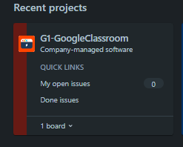

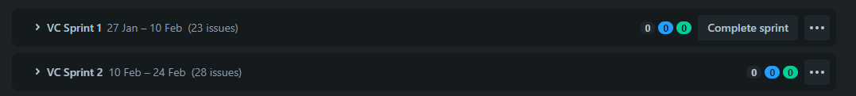  
2- Create **user story** and **description**in **backlog**following document

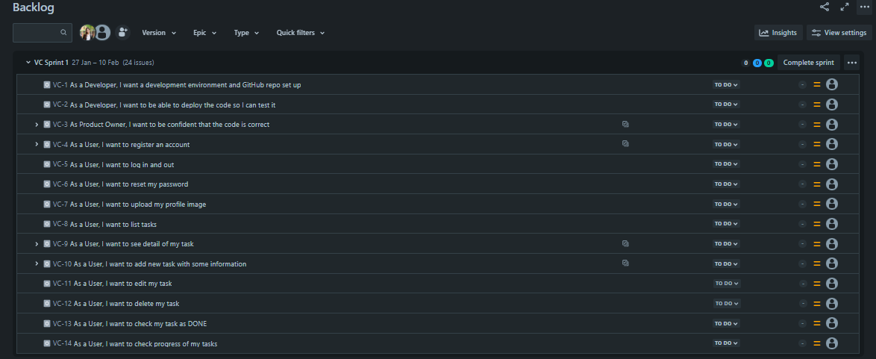  
3 - Create **sub task** and **estimate time**

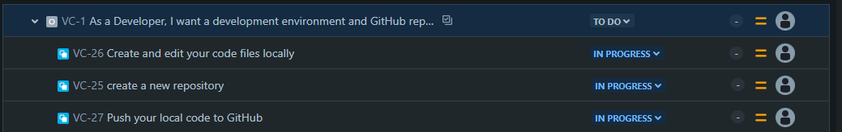

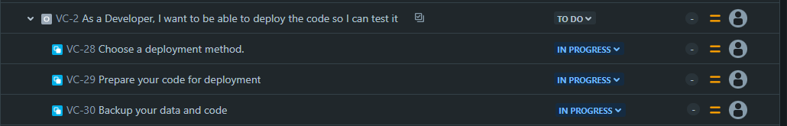

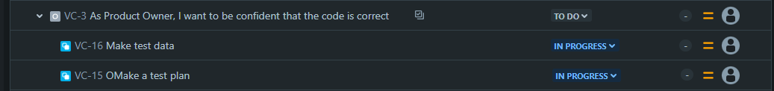

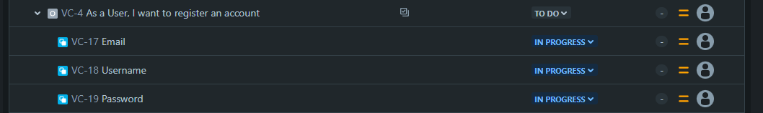





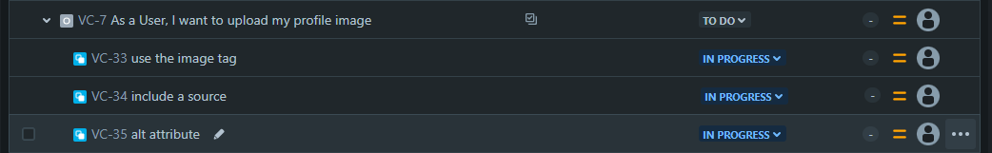

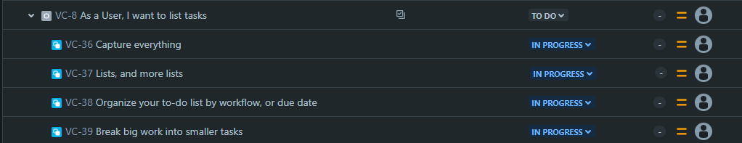



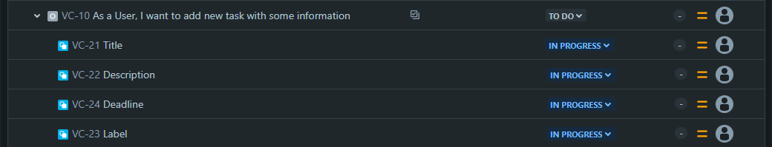

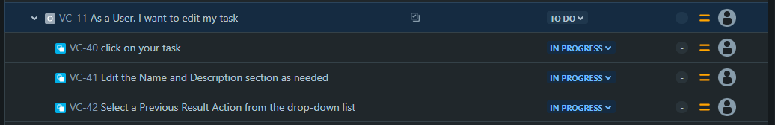



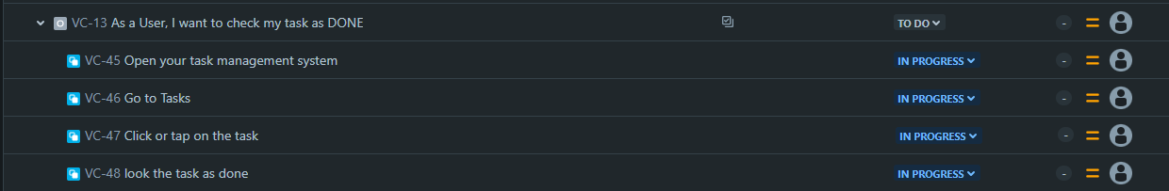

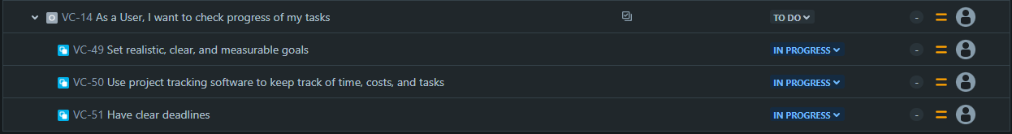  
4 - Move **sub task**to each sprint follow document

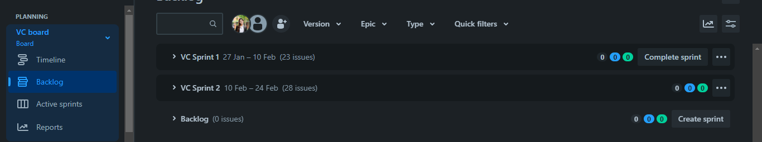

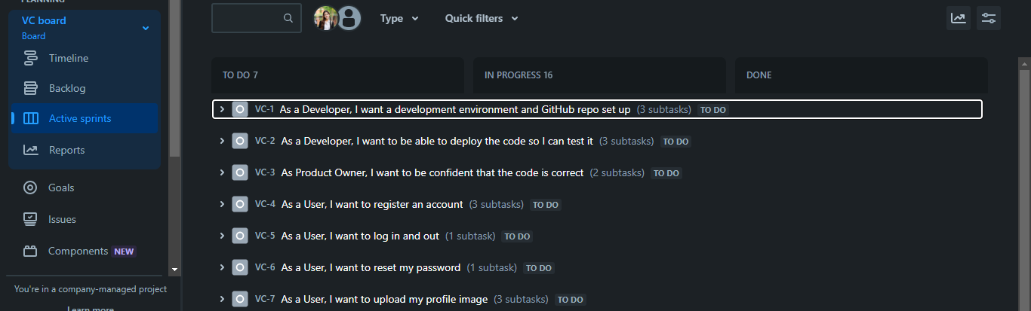

  
5 - Add [*rady.y@passerellesnumeriques.org*](https://mail.google.com/mail/?view=cm&fs=1&to=rady.y%40passerellesnumeriques.org&authuser=0) to your project